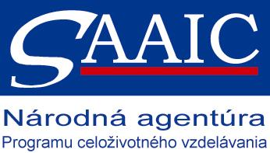

Erasmus Placements in Schools
Placement Description

SCHOOL OVERVIEW
NAME OF THE SHOOL | ZŠ s MŠ Ulica Ivana Krasku 29, Trnava
ADDRESS | Ulica Ivana Krasku 29
COUNTRY | Slovakia
WEB PAGE | www.zsmodranka.edupage.org
SHORT INFORMATION ABOUT SCHOOL | We are the school that provides pre–primary, primary and low secondary education. The school consists of 9 primary classes and there are 3 classes of kindergarten. We have got 67 children in our kindergarten who are educated by 6 teachers in three classes. The primary school has 177 pupils. There are 13 teachers and 3 tutoresses in the school staff who provide primary education to our pupils.
CONTACT PERSON | Lutzbauerová Ľubica, PaedDr.
CONTACT DETAILS  (E-MAIL, TEL. NO.) | +421 907143112, lutzbauerova@centrum.sk
REQUESTED ERASMUS STUDENT PROFILE | English fluently speaking person, able to work independently, creatively, children- loving
FIELD OF STUDIES/PROFESSIONAL AREAS OF INTEREST | Preference—languages, English, German  science, social studies
TASKS | Team-teaching in English lessons, conversation classes, English through games with young learners, widening our knowledge about cultural aspects of life
REQUIREMENTS (LANGUAGES AND OTHER COMPETENCES) | English language, ICT
PAYMENT OR OTHER BENEFITS | Cheap accommodation near the school, possibility to order lunches in our canteen ,almost family like school and school staff☺
PLACEMENT DURATION | From at least 6 to 10 months
PLACEMENT PERIOD  (FROM - TO) | Whenever from Sept.or October till May-June
OTHER INFORMATION | We have previous experiences working with Comenius assistants from Turkey and Lithuania, enabling us to make the student´s stay as pleasant as possible

